CS5242: Neural Networks and Deep Learning

Instructor: YOU, Yang ([youy@comp.nus.edu.sg](mailto:youy@comp.nus.edu.sg))

TA: ZHANG, Geng ([zhangg@u.nus.edu](mailto:zhangg@u.nus.edu))

TA: ZHANG, Yiqi ([e1110893@u.nus.edu](mailto:e1110893@u.nus.edu))

TA: ZHAO, Wangbo ([e0983526@u.nus.edu](mailto:e0983526@u.nus.edu))

Questions & Social: [nuscs5242.slack.com](http://nuscs5242.slack.com)

Fall of 2024

1. Course Description

This course gives a graduate-level introduction to deep learning and in-depth coverage of new and advanced methods in deep neural networks, as well as their underlying theory. It emphasizes approaches with practical relevance and discusses a number of recent applications of deep learning in areas like recommender systems, computer vision, natural language processing, and robotics. The methods and platforms for the implementation and evaluation of deep learning systems would be discussed. Furthermore, learners will practice employing deep learning to deal with a few applied examples using distributed computing environments. An open research project is a major part of the course.

2. Tentative Schedule

Lecture 1 (Aug 13):

Introduction to Deep Learning

<https://www.youtube.com/watch?v=yaL5ZMvRRqE>

<https://www.youtube.com/watch?v=GI4Tpi48DlA>

Lecture 2 (Aug 20):

(Shallow) Neural Networks

Lecture 3 (Aug 27):

Training Deep Networks (**assignment 1**）

Lecture 4 (Sep 3):

Convolutional Neural Network (CNN) Basics

Lecture 5 (Sep 10):

Regularization + CNN Architectures (**assignment 2**）

Lecture 6 (Sep 17):

Deep CNN Architectures

Lecture 7 (Oct 1):

Attention & Transformers (**assignment 3**)

Lecture 8 (Oct 8):

BERT (**assignment 4**)

Lecture 9 (Oct 15):

GPT

Lecture 10 (Oct 22):

Stable Diffusion (**assignment 5**)

Lecture 11 (Oct 29):

Open-Sora: Democratizing Efficient Video Production for All (**assignment 6**)

<https://github.com/hpcaitech/Open-Sora>

Lecture 12 (Nov 5):

Distributed Training Techniques

Lecture 13 (Nov 12):

Presentation

3. Evaluation and Grading

Weekly homework (60%)

Please form a team of 2-4 students for the final project

1. Each team gives a talk or presents a poster (10%)
2. Each team finishes a report (30%)

The workload can be reduced (depending on the feedback from the students)

* Homework requirement and deadline
  + **6** assignments (assigned on weeks 3 ,5, 7, 8, 10, 11 due in one week). Each assignment will take two to five hours to finish for most students. Lecture 12 will be left to prepare the final report.
  + Every week, TA will give a brief introduction of assignments in the tutorial.
  + The assignments are published by Jupyter notebook, which can be run on google colab Each assignment will have several tasks, e.g., implementing some key functions/algorithms. There can also be some theoretical problems given in pdf format.
  + Please finish the tasks according to the instructions. Only change the code in the required snippets and **DO NOT** change others or add new code/text snippets.
  + Submission: rename the assignment file as "StuID_Name_assignment-1.ipynb" or "StuID_Name_assignment-1.pdf". e.g., 'A0100000J_Wang-Wenjie_assignment-1.ipynb'. And submit it to **Canvas**.
  + In addition to the “.ipynb” file, you may need to submit another “.py” file. More details can be found in the assignments.
  + The submission deadline for each assignment is 23:59pm on Friday of the next week.
  + Please follow the instructions strictly, otherwise you might be **penalized**.
  + If you have any questions on assignments and tutorial, please contact TAs
* Final project report
  + Send it to [zhangg@u.nus.edu](mailto:zhangg@u.nus.edu) and cc to [yang.you.cs@gmail.com](mailto:yang.you.cs@gmail.com) before the **23rd of November**
  + Use NeurIPS format
    - <https://nips.cc/Conferences/2020/PaperInformation/StyleFiles>
    - The report should have at most 9 pages (contents & references)

4. Module Information

* Class Time: Tuesday 6:30-8:30pm
* Tutorial Time: Tuesday 8:30-9:30pm
* Questions & Answers: nuscs5242.slack.com
* Location: Seminar Room 1 (COM1-0206)
* Zoom: 399 799 8157
* Slides and Lecture Recordings: <https://drive.google.com/drive/folders/13WOEeQKr2gcA-z2eD64hhEUhUE6TkU1l?usp=drive_link>

5. Final Project

1. Please form a team of 2-4 students for the final project

* Each team gives a talk or presents a poster (10%)
* Each team finishes a report (30%)

1. Fill this form after finding your teammates

<https://docs.google.com/spreadsheets/d/1cqKzC-Eoxg1EHxt2xei90bV2Db7S2qybTpaVYypnmy4/edit?gid=0#gid=0>

1. Presentation

* 12th Nov. (the last lecture at Week 13, Tues.)
* Each team will be giving around 4 mins according to last semester.

1. Report

* Use NeurIPS format: <https://nips.cc/Conferences/2020/PaperInformation/StyleFiles>
* The report should have at most 9 pages (contents & references)
* Send it to zhangg@u.nus.edu and cc to yang.you.cs@gmail.com before the 23rd Nov.

1. Project Topic

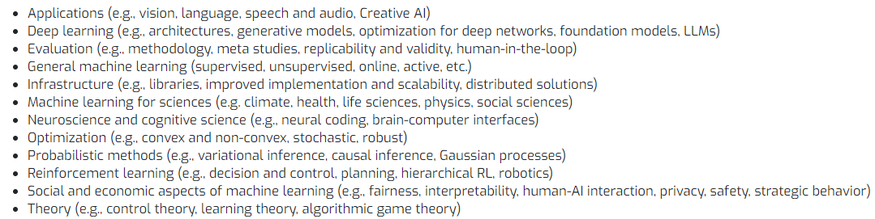

We encourage you to find topic of your interests

If you have any problem in topic selection, please drop an email to TAs or DM to us on Slack

1. Project Evaluation

The three parts will be scaled to 40% of final grade.

* Report (50)

motivation (5) novelty (5), related work (5), organization(5), method (10), evaluation (20)

* Code (10)

reproducibility (5), readability (5)

* Presentation (20)

PS:

If you want to work on the project with the instructor, there are some project options:

1. Building your own AI APP based on video generation model like Open-Sora

2. Minimizing the latency of AI models (llama2/stable diffusion/mistral) inference on your cell phone, your laptop, and a GPU server. What is the best system so far? How can you beat it?